**Physics Final Exam Suggestion**

**Lecture_1**

**The particle-like properties of electromagnetic radiation**

**Photon:**

* Like an electromagnetic wave, photons move with the speed of light;
* They have zero mass and rest energy;
* They carry energy and momentum, which are related to the frequency and wavelength of the electromagnetic wave by E = hf and p = h/λ ;
* They can be created or destroyed when radiation is emitted or absorbed; • They can have particle-like collisions with other particles such as electrons.

**Wave particle duality of Light:**

Light can act as a wave or as a particle. This is known as the wave-particle duality.

**Wave theory of light:**

Light is an electromagnetic wave that consists of oscillating electric and magnetic fields. The energy carried by the light wave is stored in the electric and magnetic field.

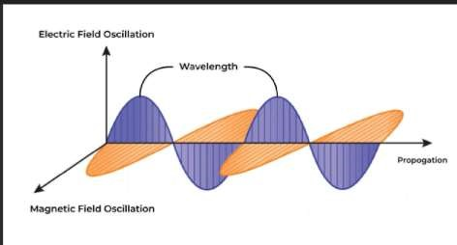

Both the single and double slit experiments confirmed this theory. Light is directed at slits, leading to diffraction and interference of the light waves. This formed a dark/bright fringe pattern on a screen.

**Particle theory of light:**

Light consists of discrete particles known as photons that carry identical quantity of energy that depends on frequency of oscillation.



Each photon is a massless particle that is basically a packet of energy given by hf. Two important experiments are served to confirm the particle theory of light, i.e. photoelectric effect, compton effect.

**Problem_3:**

An x-ray photon of wavelength 10.0 pm is scattered through 110.0° by an electron. What is the kinetic energy of the re coiling electron?

**Solution :**

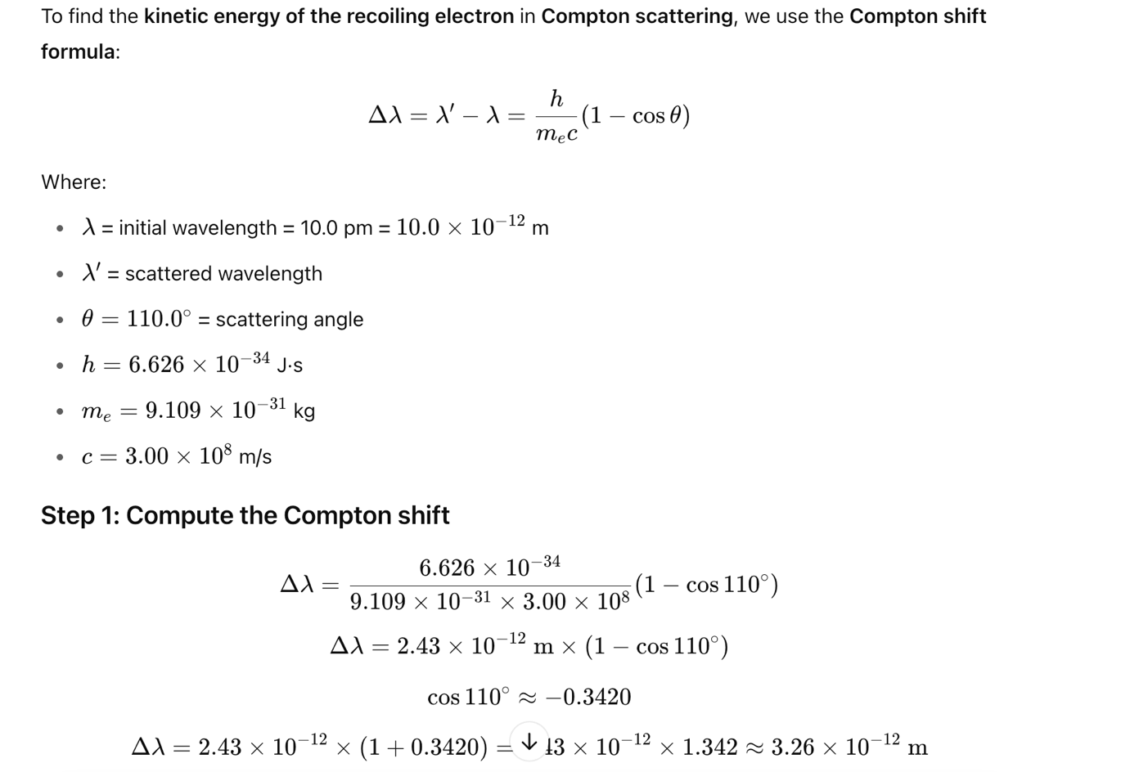

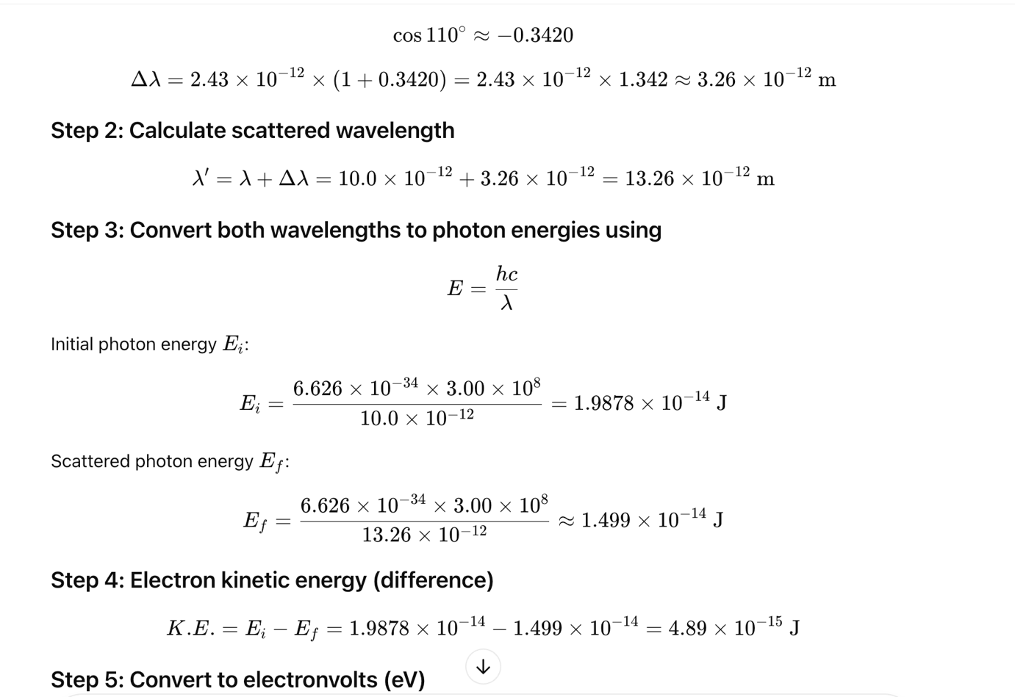

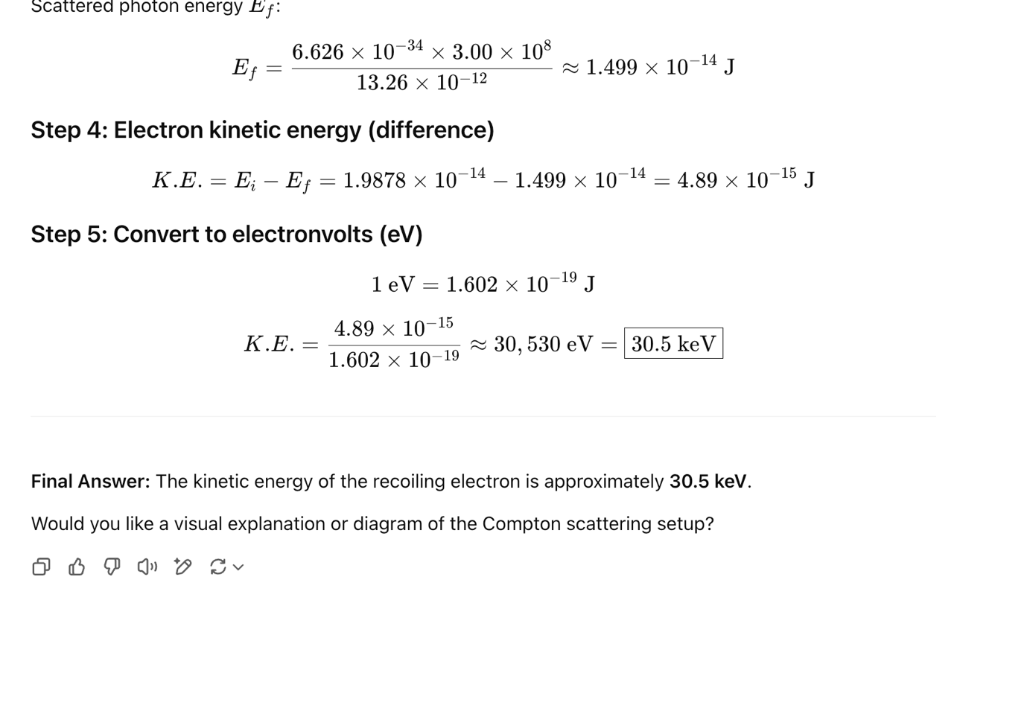

**Poblem_4:**

In a Compton scattering experiment, x-rays scattered through an angle of 37.0° with respect to the incident x-rays have a wavelength of 4.20 pm. What is the wave length of the incident x-rays?

**Solution:**

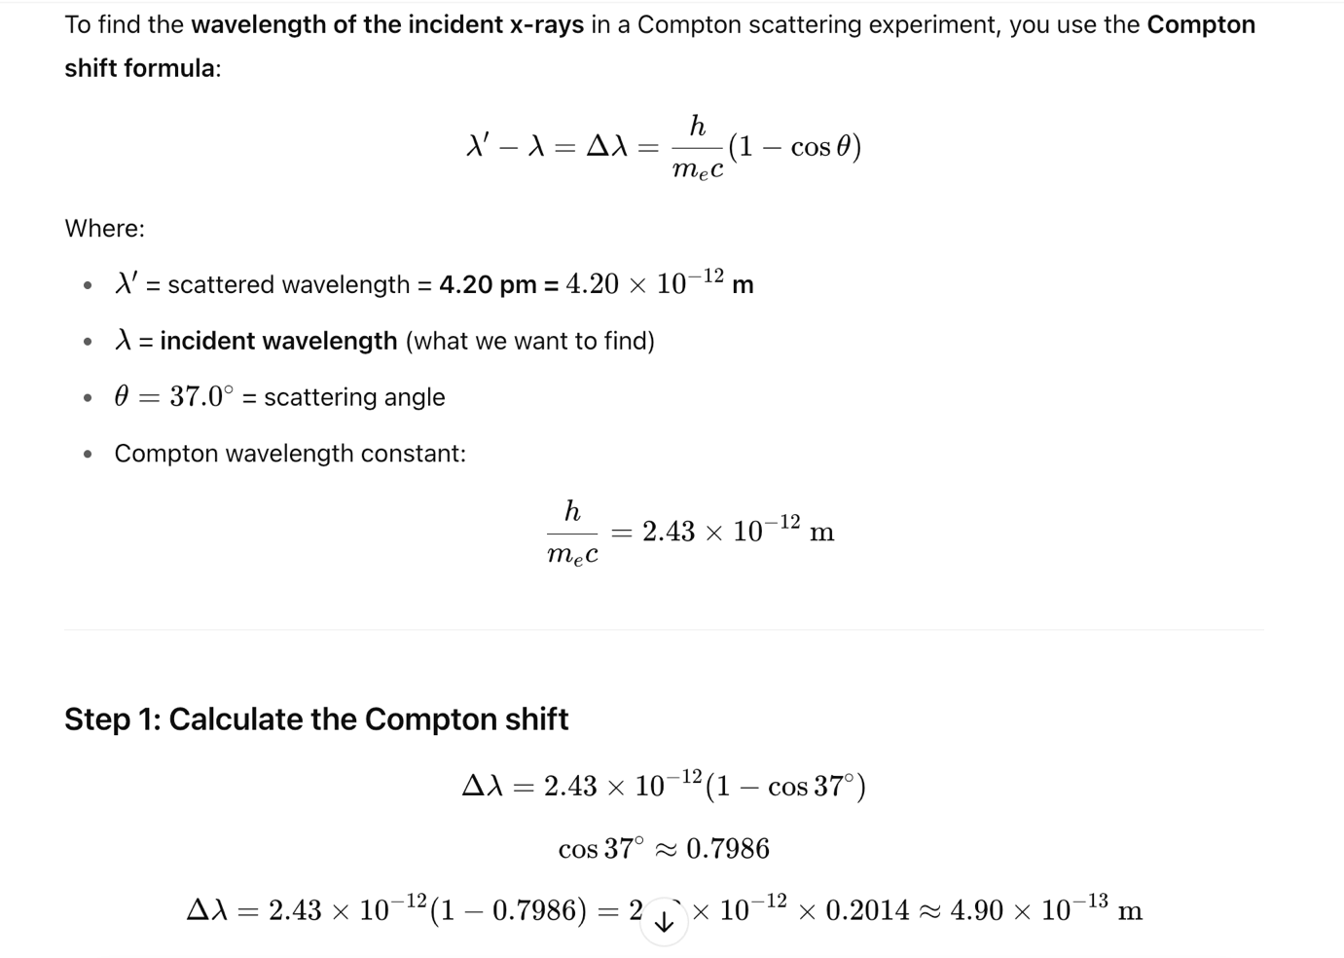

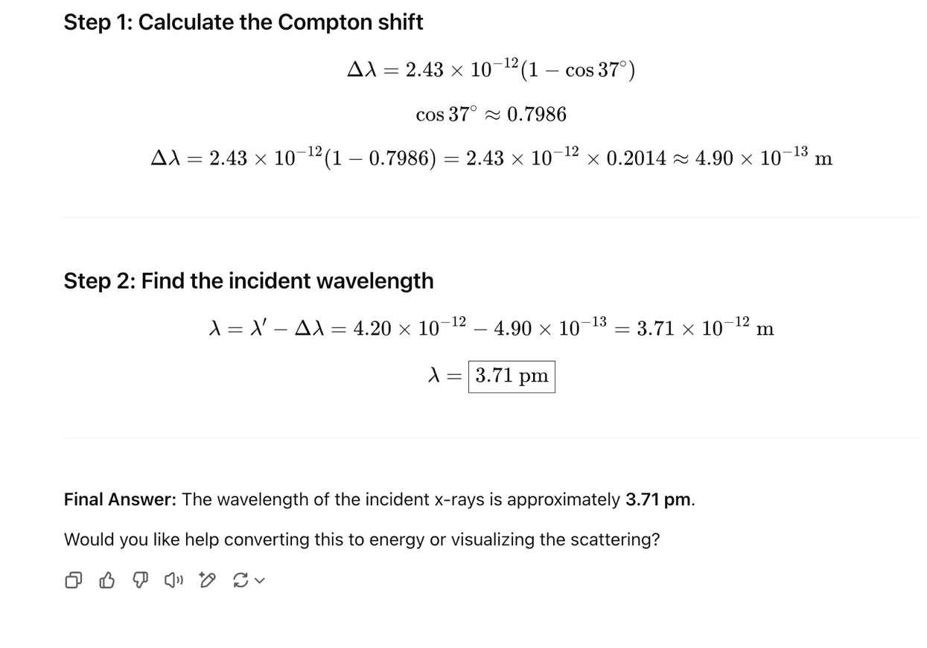

**Lecture-2**

**Problem_1:**

(a) At what wavelength does a room-temperature (T = 20⚬C) object emit the maximum thermal

radiation? (b) To what temperature must we heat it until its peak thermal radiation is in the red region

of the spectrum (λ = 650 nm)? (c) How many times as much thermal radiation does it emit at the higher temperature?

**Solution:**

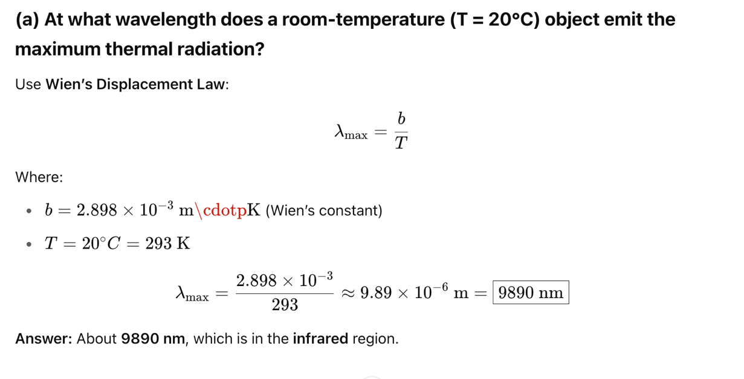

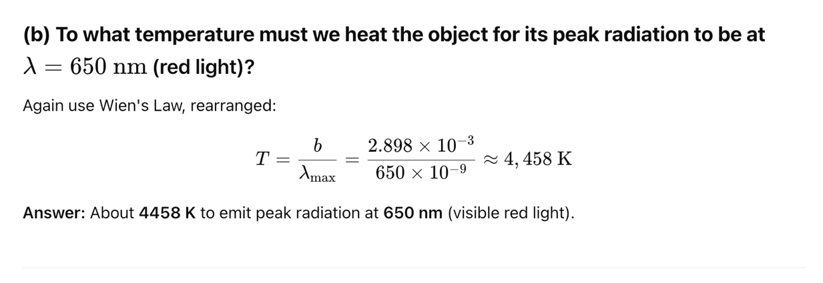

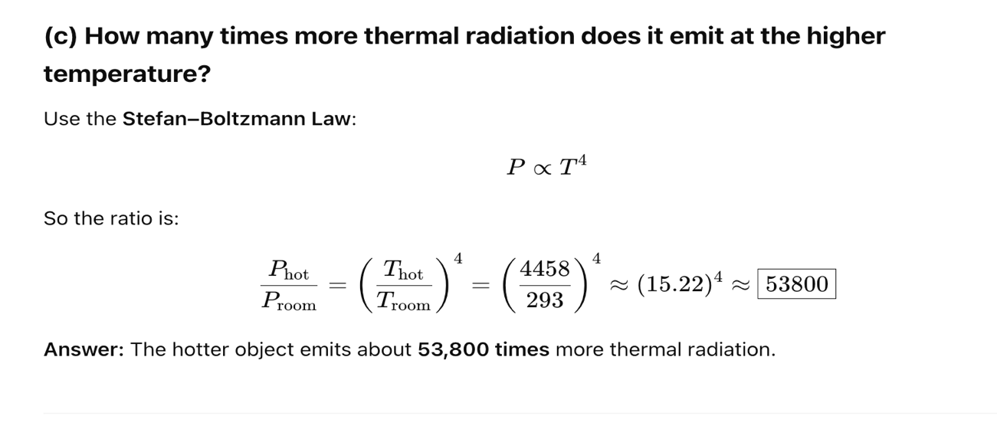

**Pair Production and Annihilation:**

|  |  |
| --- | --- |
|  |  |

Figure: Pair production. (a) A photon passes near an atomic nucleus. (b) The photon vanishes by creating an electron-positron pair. The nucleus recoils with an insignificant kinetic energy but, due to its large mass, with a significant momentum.

An energetic photon can create a positron and an electron where no such particles existed before. The photon is totally absorbed in the process. Energy must be con served in any process, so in order for pair production to occur,



The total energy of a particle with mass is the sum of its kinetic energy and its rest energy (the energy of the particle when at rest). A particle of mass m has rest energy.



Thus, a photon must have an energy of at least 2mec2 in order to create an electron-positron pair. If the photon’s energy is greater than 2mec2, the excess energy appears as kinetic energy of the electron and positron.

**Pair Annihilation:**

|  |  |
| --- | --- |
|  |  |

Figure: Pair annihilation. (a) An electron and positron vanish, creating (b) a pair of photons.

**Problem_2:**

Find the threshold wavelength for a photon to produce an electron-positron pair.

Solution:

The minimum photon energy to create an electron-positron pair is



Now we find the wavelength of a photon with this energy.



Then the wavelength is



**Lecture-3**

**De Broglie Wave Equation:**

According to Planck’s quantum theory energy of a photon is,

𝐸 = ℎ𝜐

Here h=Planck’s constant =6.63 × 10−34 𝐽𝑠, 𝜐 = frequency of the photon.

If the mass of a photon particle m, the according to Einstein’s mass energy relation,

𝐸 = 𝑚𝑐2

Comparing those equation we can write,

ℎ𝜐 = 𝑚𝑐2

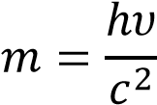

Suppose, the momentum of photon, P. So, 𝑝 = 𝑚𝑎𝑠𝑠 𝑜𝑓 𝑎 𝑝ℎ𝑜𝑡𝑜𝑛 ×

𝑣𝑒𝑙𝑜𝑐𝑖𝑡𝑦 𝑜𝑓 𝑡ℎ𝑒 𝑝ℎ𝑜𝑡𝑜𝑛

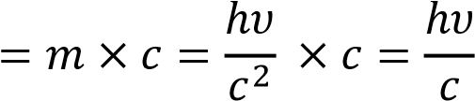

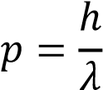

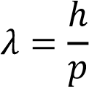

**Problem_1:**

An electron diffraction experiment is performed using electrons that have been accelerated through a potential difference of 8.0 kV. (a) Find the de Broglie wavelength of the electrons. (b) Find the wavelength and energy of x-ray photons that would give a diffraction pattern with maxima at the same angles.

Solution:

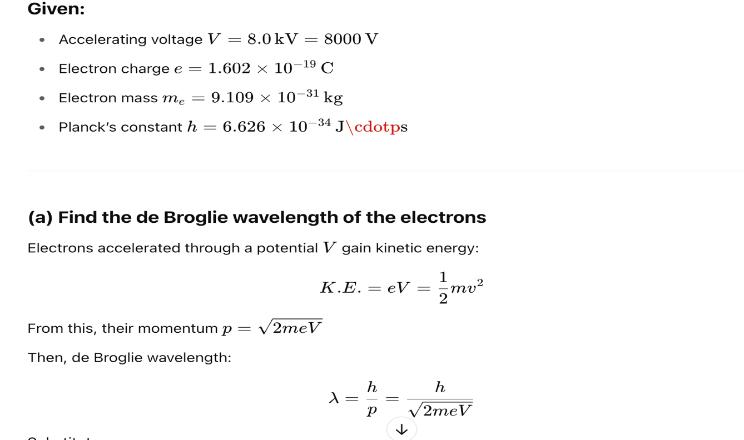

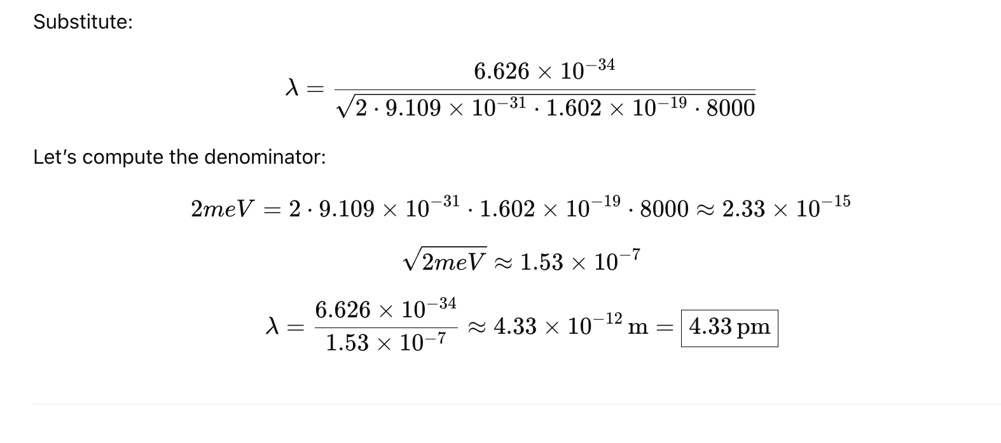

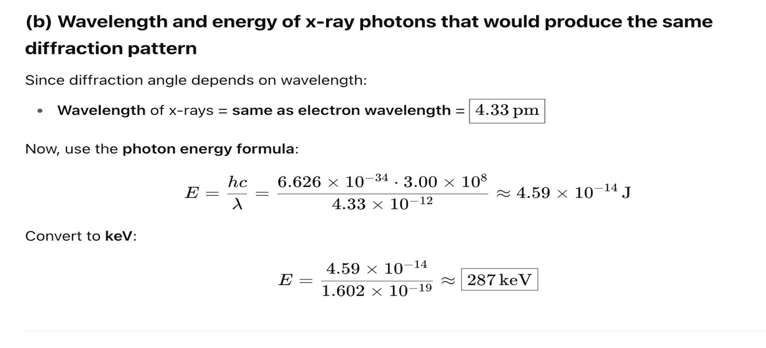

**The uncertainty principle:**

We cannot know both the position and speed of a particle, such as a photon or electron, with perfect accuracy. If Δx is the uncertainty in the x-coordinate of position and ∆𝑝𝑥 is the uncertainty in the x-component of the momentum, then



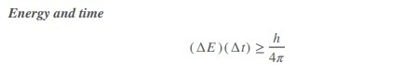

**Problem_2:**

Our lungs contain approximately 500 million alveoli, which are the small, hollow chambers lined with a membrane that allows the exchange of oxygen and carbon dioxide in our blood. Consider the situation of an electron located in one of these sacks and (a) calculate the uncertainty in its momentum using the

Heisenberg uncertainty principle. For the uncertainty in the electron’s position, use the diameter of the alveoli, which is approximately 0.05 mm. Next, assume that at some instant in time, the momentum of the electron is equal to the uncertainty in its momentum and (b) calculate the kinetic energy of the electron.

**Solution:**

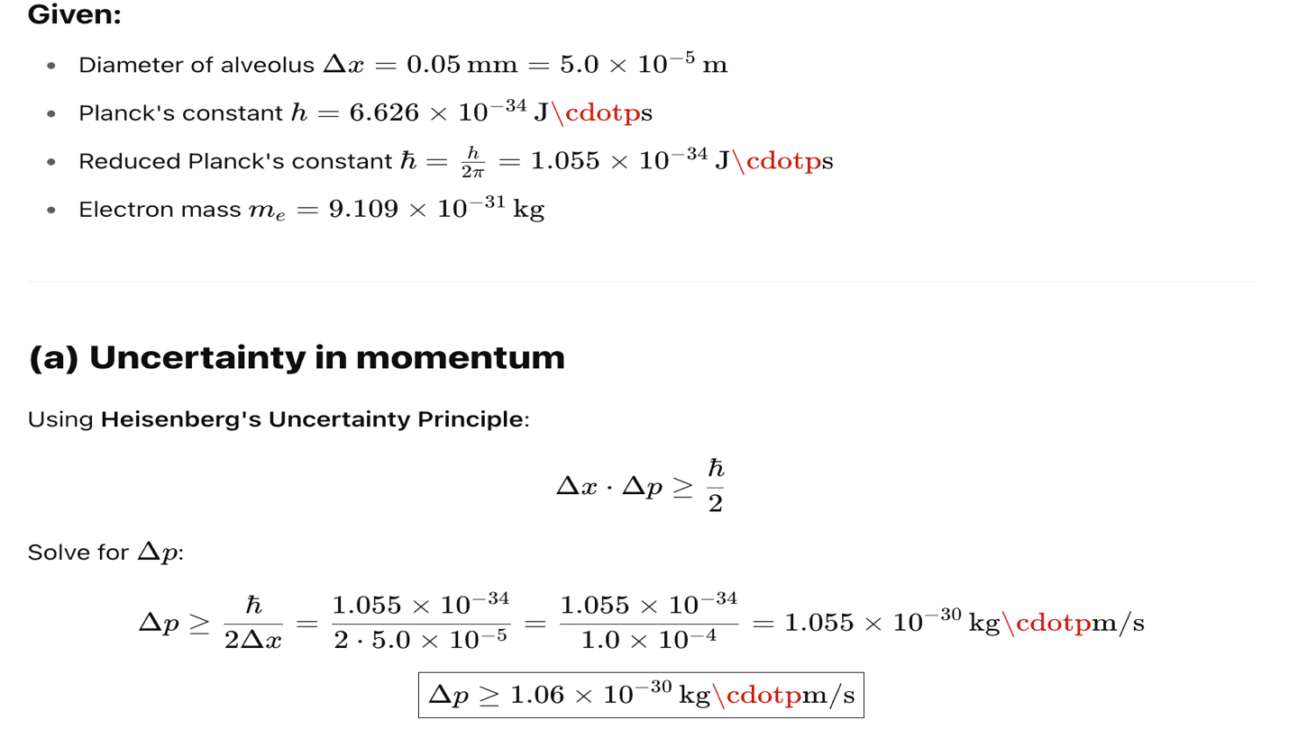

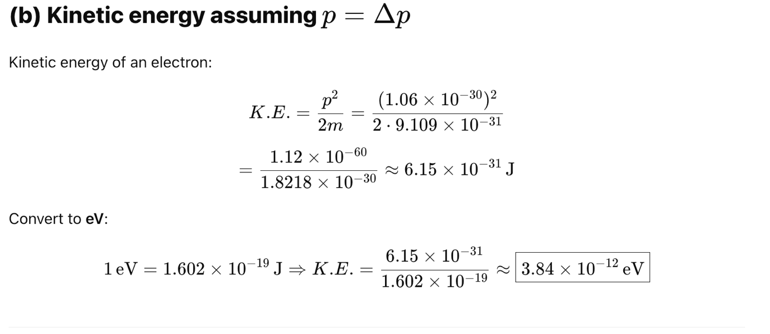

**Lecture – 4**

**Problem_3:**

The 238U nuclide can decay by emitting an alpha particle:



(a) Find the disintegration energy. (b) Find the kinetic energy of the alpha particle, assuming the parent 238U nucleus was initially at rest.

Solution:

1. The total mass of the products is



The change in mass is



According to Einstein’s mass-energy relation, the change in rest energy is



By conservation of energy, the kinetic energy of the products is 4.2698 MeV more than the kinetic energy of the parent. The disintegration energy is 4.2698 MeV.

1. Assuming for the moment that the daughter nucleus and the alpha particle can be treated nonrelativistically, their kinetic energies are related to their momenta by



Momentum conservation says that their momenta must be equal in magnitude and opposite in direction. Therefore, the ratio of the kinetic energies is



The two kinetic energies must add up to 4.2698 MeV.



Now we substitute for KTh from the kinetic energy ratio.



Solving yields Kα = 4.198 MeV.

**Problem_4:**

Find the kinetic energy of the alpha particle emitted by the decay of 210Po.

Solution:

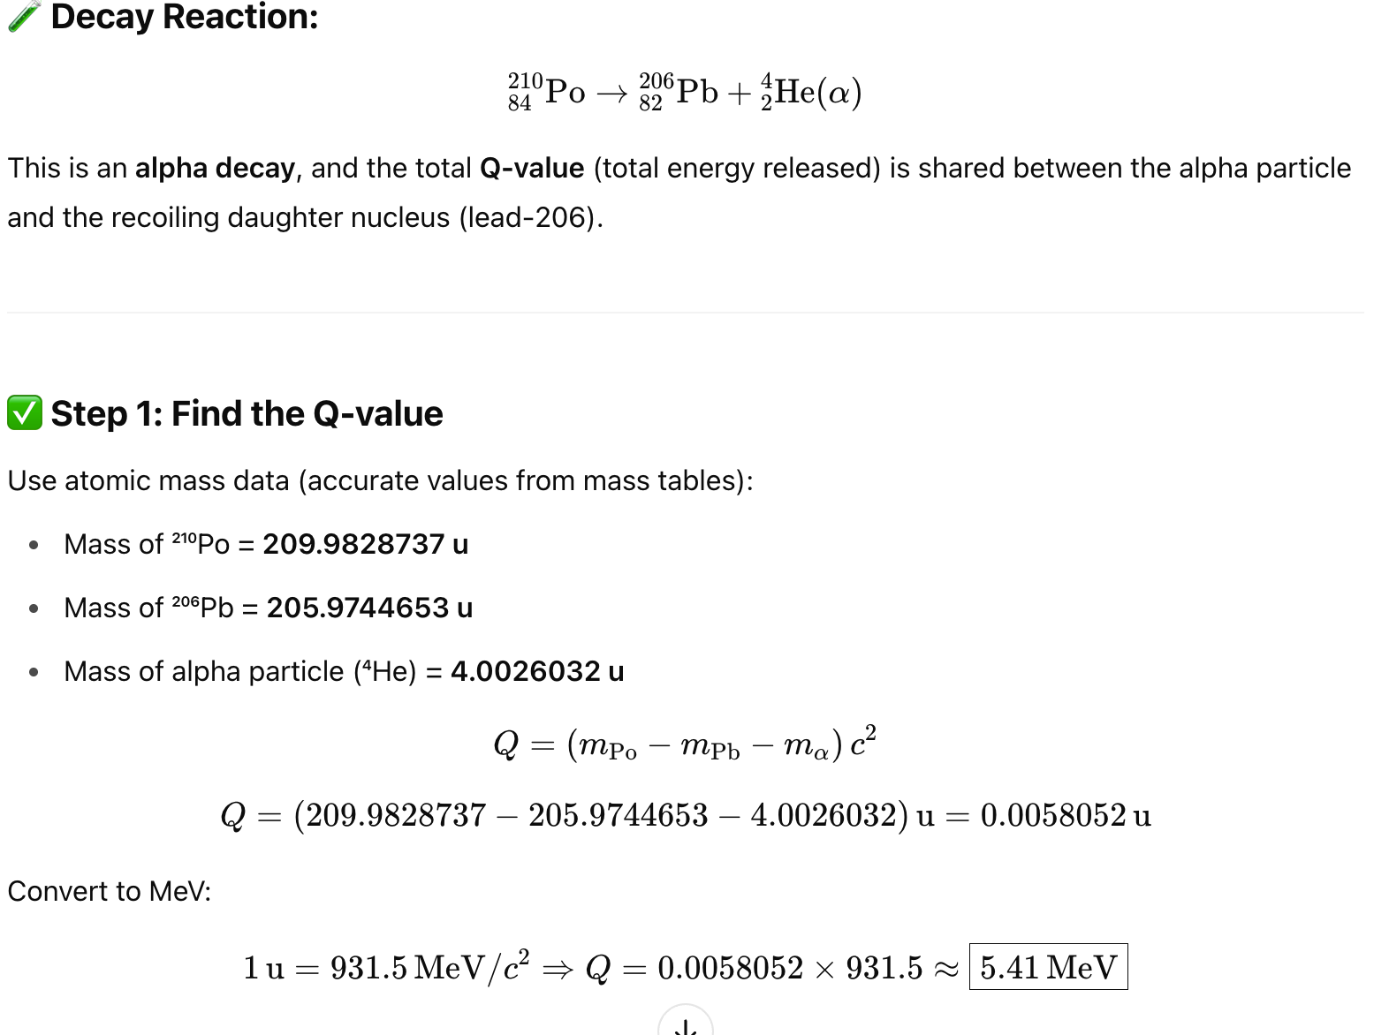

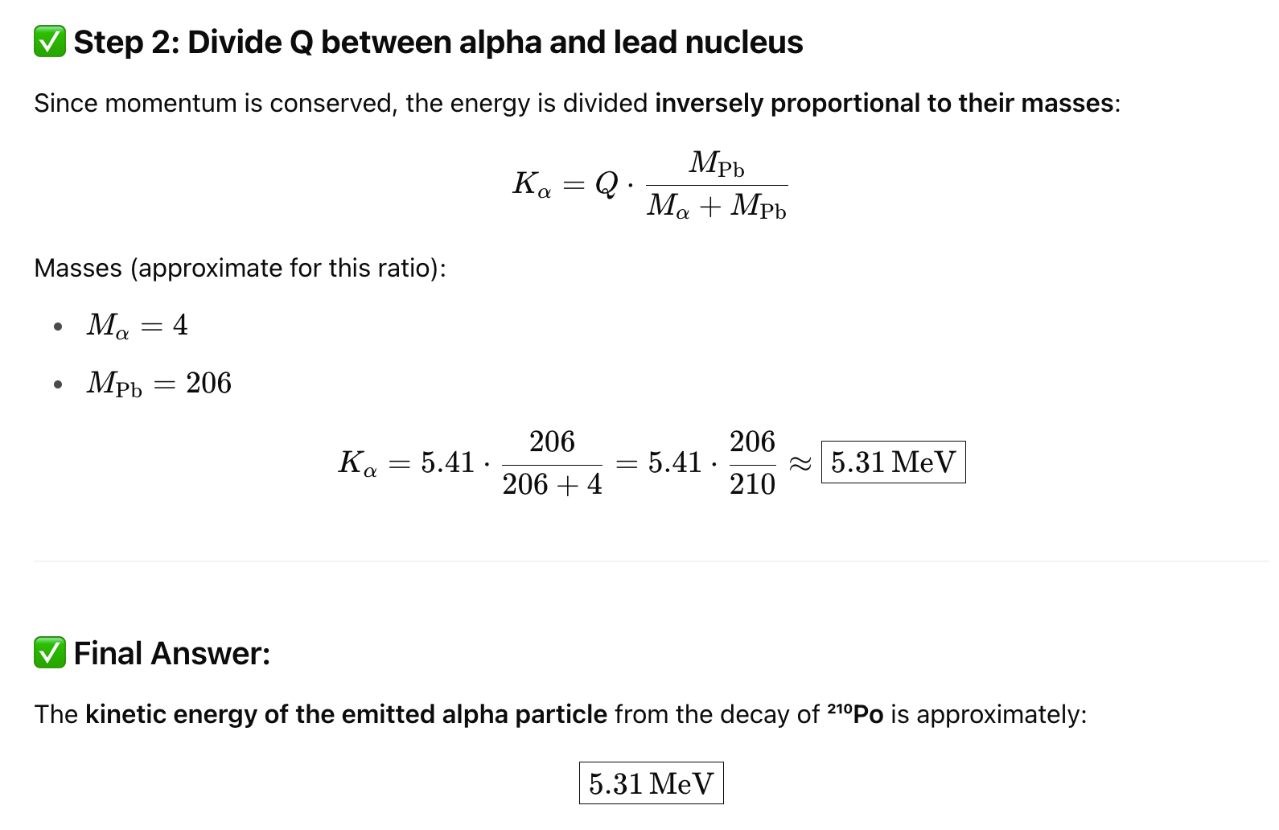

**Beta Decay:**



**Electron Capture:**



**Lecture_5 & 6**

**Relativistic Doppler Effect:**

When a light source and a light detector move directly relative to each other, the wavelength of the light as measured in the rest frame of the source is the proper wavelength 𝜆0. The detected wavelength 𝜆 is either longer (a red shift) or shorter (a blue shift) depending on whether the source–detector separation is increasing or decreasing.

**DOPPLER EFFECT FOR LIGHT:**

Let f0 represent the proper frequency of the source—that is, the frequency that is measured by an observer in the rest frame of the source. Let f represent the frequency detected by an observer moving with velocity **v** relative to that rest frame. Then, when the direction of **v** is directly away from the source,

**.......(1)**



**Transverse Doppler Effect:**

If the relative motion of the light source is perpendicular to a line joining the source and detector, the detected frequency f is related to the proper frequency f0 by



**Low-Speed Doppler Effect:**

For low speeds (𝛽 ≪1), Eq.(1) can be expanded in a power series in 𝛽 and approximated as

.......(3)

The corresponding low-speed equation for the Doppler effect with sound waves (or any waves except light waves) has the same first two terms but a different coefficient in the third term. Thus, the relativistic effect for low-speed light sources and detectors shows up only with the third term.

A police radar unit employs the Doppler effect with microwaves to measure the speed v of a car. A source in the radar unit emits a microwave beam at a certain (proper) frequency f0 along the road. A car that is moving toward the unit intercepts that beam but at a frequency that is shifted upward by the Doppler effect due to the car’s motion toward the radar unit. The car reflects the beam back toward the radar unit. Because the car is moving toward the radar unit, the detector in the unit intercepts a reflected beam that is further shifted up in frequency. The unit compares that detected frequency with f0 and computes the speed v of the car.

**Astronomical Doppler Effect:**

In astronomical observations of stars, galaxies, and other sources of light, we can determine how fast the sources are moving, either directly away from us or directly toward us, by measuring the Doppler shift of the light that reaches us. If a certain star were at rest relative to us, we would detect light from it with a certain proper frequency f0. However, if the star is moving either directly away from us or directly toward us, the light we detect has a frequency f that is shifted from f0 by the Doppler effect. This Doppler shift is due only to the radial motion of the star (its motion directly toward us or away from us), and the speed we can determine by measuring this Doppler shift is only the radial speed v of the star—that is, only the radial component of the star’s velocity relative to us

Suppose a star (or any other light source) moves away from us with a radial speed v that is low enough (beta is small enough) for us to neglect the third term in Eq.-3. Then we have



Because astronomical measurements involving light are usually done in wavelengths rather than frequencies, let’s rewrite the above Eq.

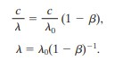

Using binomial expansion we can write,

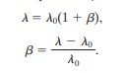

**......(4)**

The difference ∆𝜆 is the wavelength Doppler shift of the light source. We enclose it with an absolute sign so that we always have a magnitude of the shift. Equation 4 is an approximation that can be applied whether the light source is moving toward or away from us but only when v ≪ c.

**Relativistic Momentum:**

Consider a particle moving with constant speed v in the positive direction of an x axis. Classically, its momentum has magnitude



in which ∆𝑥 is the distance it travels in time ∆𝑡.To find a relativistic expression for momentum, we start with the new definition



Here, as before, ∆𝑥 is the distance traveled by a moving particle as viewed by an observer watching that particle. However, ∆𝑡0 is the time required to travel that distance, measured not by the observer watching the moving particle but by an observer moving with the particle. The particle is at rest with respect to this second observer; thus that measured time is a proper time.

Using the time dilation formula,∆𝑡 =𝛾∆𝑡0, we can then write



However, since ∆𝑥/∆𝑡 is just the particle velocity v, we have



**Problem_4:**

Cosmic rays collide with atoms or molecules in the upper atmosphere (Fig.). If a proton moving at 0.70c makes a head-on collision with a nitrogen atom, initially at rest, and the proton recoils at 0.63c, what is the speed of the nitrogen atom after the collision? (The mass of a nitrogen atom is about 14 times the mass of a proton.)

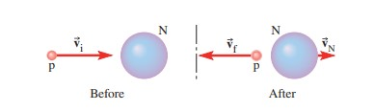

**Solution:**

Choose the direction of the proton’s initial velocity as the +x-direction. The initial momentum of the proton

is

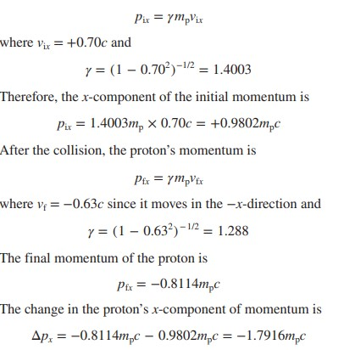

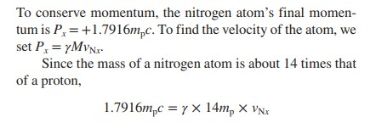

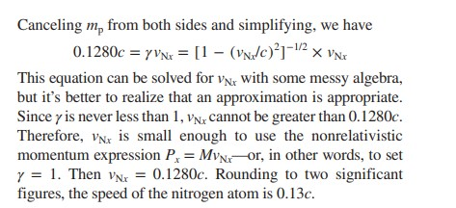

**Problem_5:**

The radioactive decay of carbon-14 into nitrogen-14 (14C→14N + e− + v) releases 156 keV of energy (Fig.).

If all of the energy released appears as the kinetic energy of the electron, how fast is the electron moving?

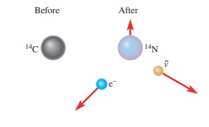

**Solution:**

The rest energy of the electron is



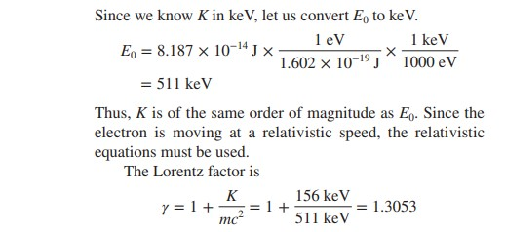

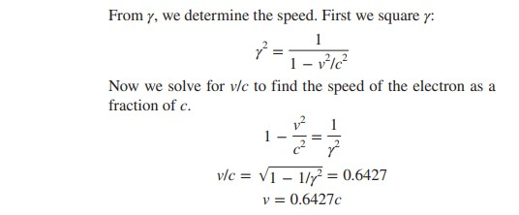

**Lecture – 7**

**Problem_3:**

A piece of charcoal (essentially 100% carbon) from an archaeological site in Egypt is subjected to radiocarbon dating. The sample has a mass of 3.82 g and a 14C activity of 0.64 Bq. What is the age of the charcoal sample?

**Solution:**

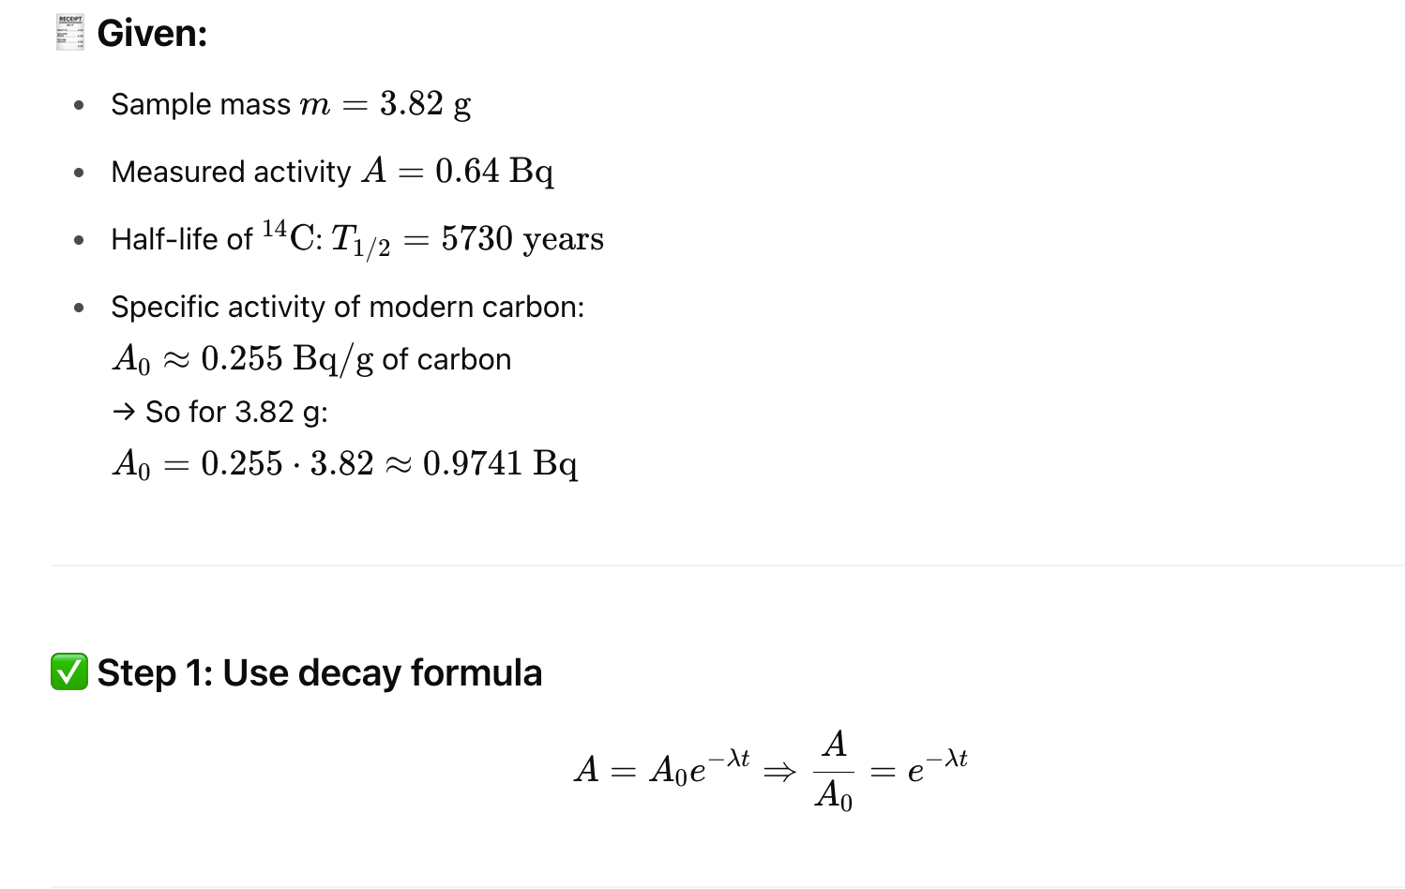

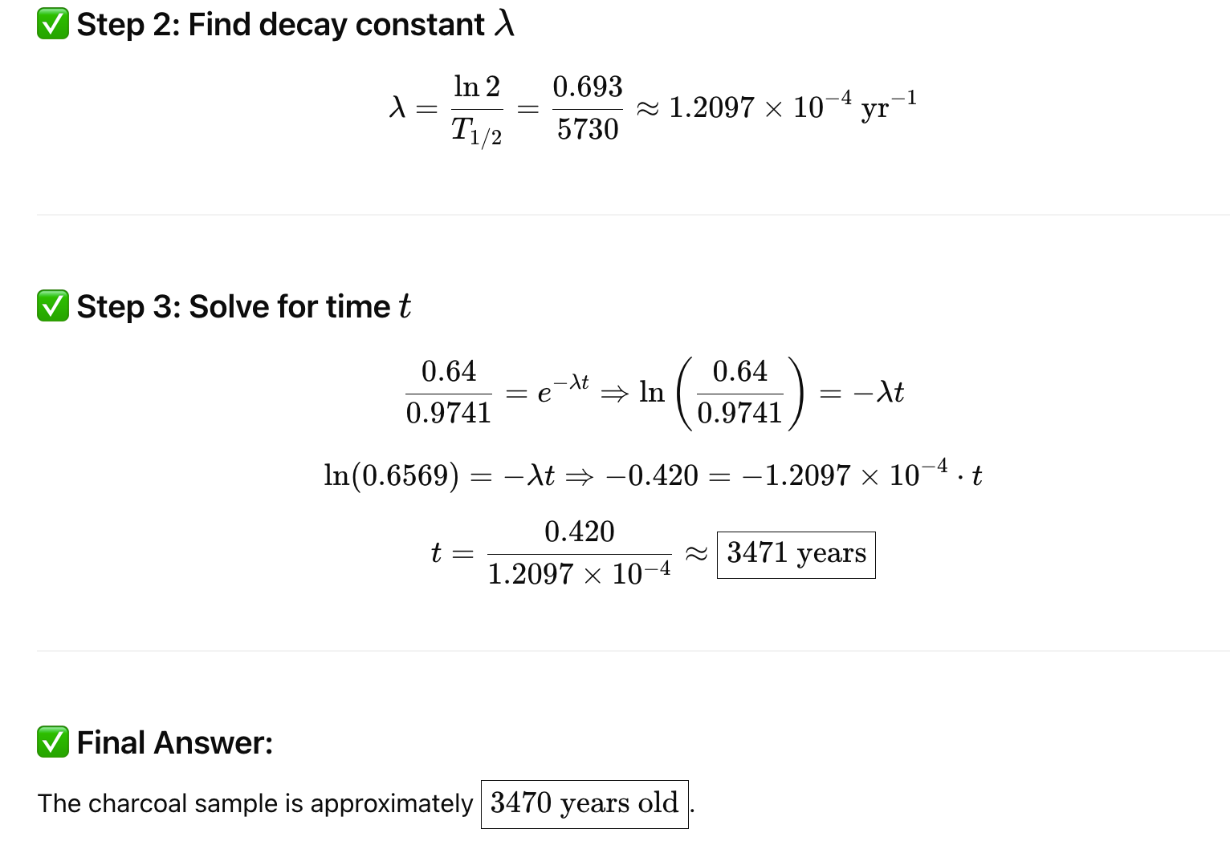

**Problem_4:**

By what percentage does the 14C activity of a nonliving sample decrease in one year?

Solution:

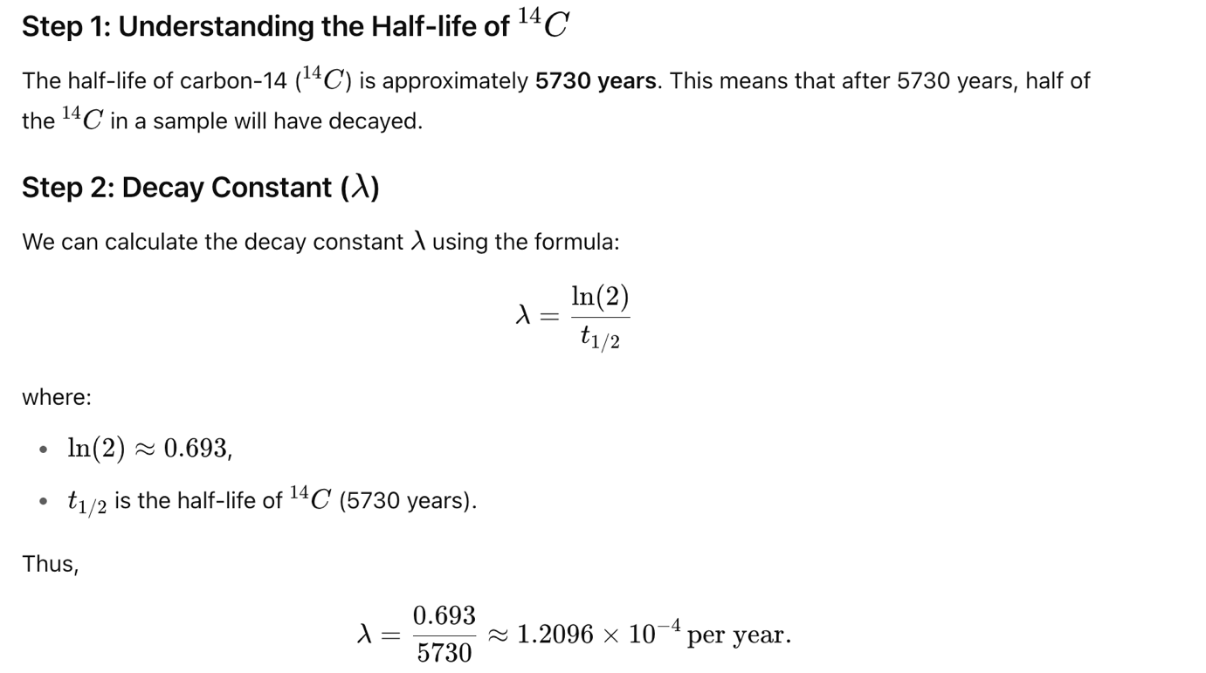

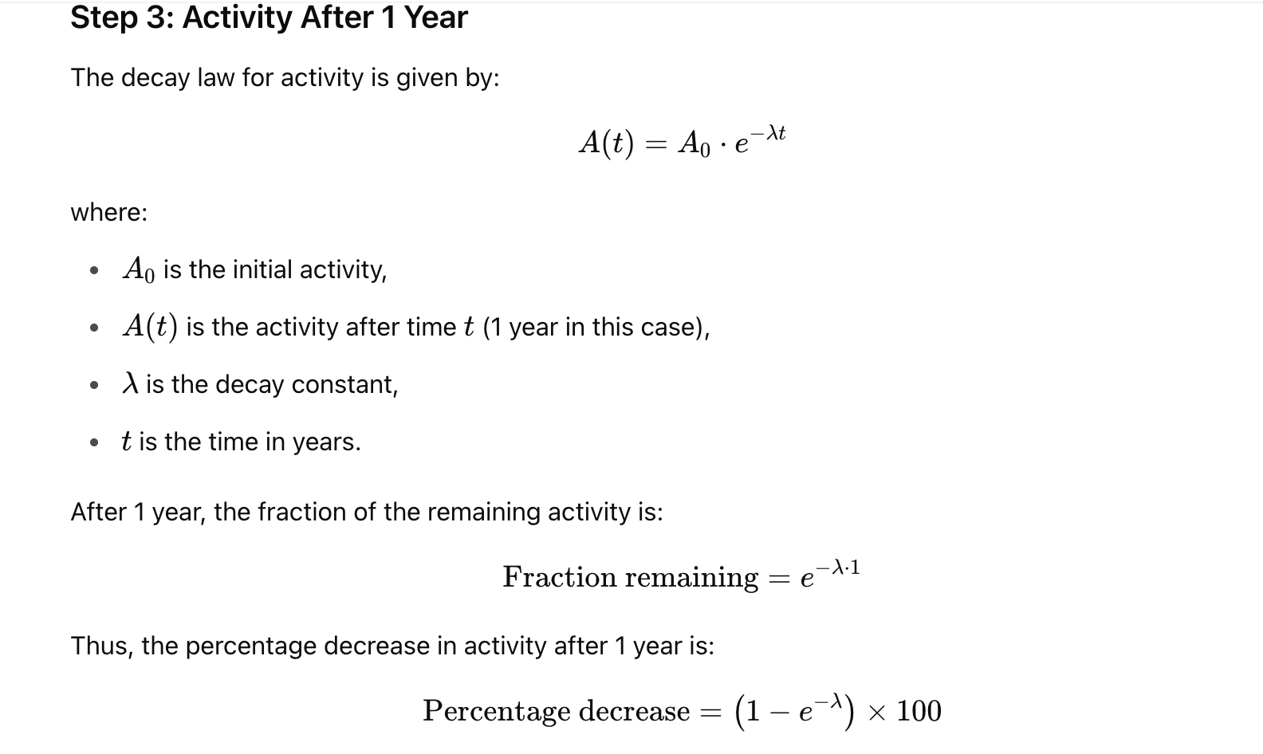

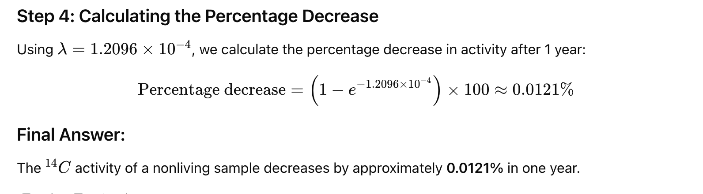

**X-ray Diffraction: Bragg’s law:**

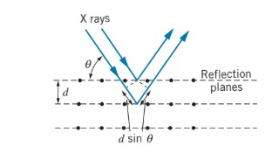

**Figure:** A beam of X rays reflected from a set of crystal planes of spacing d. The beam reflected from the second plane travels a distance 2dsinθ greater than the beam reflected from the first plane.

Suppose the rows of atoms are a distance d apart in the crystal. Then a portion of the beam is reflected from the front plane, and a portion is reflected from the second plane, and so forth. The wave fronts of the beam reflected from the second plane lag behind those reflected from the front plane, because the wave reflected from the second plane must travel an additional distance of 2dsin θ, where θ is the angle of incidence as measured from the face of the crystal. (Note that this is different from the usual procedure in optics, in which angles are defined with respect to the normal to the surface.) If this path difference is a whole number of wavelengths, the reflected beams interfere constructively and give an intensity maximum; thus the basic expression for the interference maxima in X-ray diffraction from a crystal is



This result is known as **Bragg’s law for X-ray diffraction.**

**Problem_5:**

A single crystal of table salt (NaCl) is irradiated with a beam of X rays of wavelength 0.250 nm, and the first Bragg reflection is observed at an angle of 26.3 degree. What is atomic spacing of NaCl?

**Solution:** Do yourself.

**Problem_6:**

Assuming that your surface temperature is 98.6°F and that you are an ideal blackbody radiator (you are close), find (a) the wavelength at which your spectral radiancy is maximum, (b) the power at which you emit thermal radiation in a wavelength range of 1.00 nm at that wavelength, from a surface area of 4.00 cm2.

Solution:

1. With T= 98.60F =310 K, we use Wien’s law and find the wavelength that corresponds to spectral radiancy maximum to be

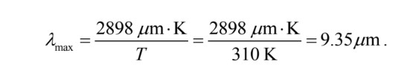

1. With 𝜆 = 9.35 × 10−6 𝑚, and T = 310 K, the spectral radiancy is

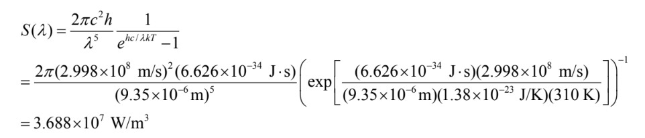

For small range of wavelength, the radiated power may be approximated as

